St Paul’s CE Primary School
Weekly Learning Schedule – Year 4
Week Beginning: 15/06/20

Monday 15th June 2020
English | Talk Time – Let’s Play Football!  Look at the picture and discuss:  - What do you think of this setting?  - Is this a good place to play football? Why/why not?  - What are the pros? Cons?  - Which half/side do you think has the advantage?  - If you were playing here, how would you adapt to this pitch?  - Why do you think this pitch was built here?  Task:  - Write a guide book for playing football on this type of pitch. Include details such as what to do if you lose the ball and player safety. Think about where the spectators might stand.
Maths | TT Rockstars  - 30 minutes times table practice each day
White Rose Maths Lesson 1 https://whiterosemaths.com/homelearning/year-4/
- Summer Term Week 8 (alternative plan) activity sheets and answers will be sent home via email.
- Lesson 1: Subtract two 4-digit numbers – no exchange
- Before this lesson you may wish to recap subtracting using the place value chart below and counters.
- Watch the video, stopping at certain points to complete the tasks and to check your child’s understanding. Use the place value chart if they require a visual prompt.
- Complete the lesson one activity sheet, encouraging your child to use the space available to show their working out.
Wider Curriculum | Termly Topic – lesson 1  - Using the time-lapse videos and pictures online look at images of Waterloo Bridge and Hungerford Bridge today – discuss what can be seen in terms of buildings, road layout, human use etc. Make comparisons with Monet’s work.  https://www.youtube.com/watch?v=lrFUY65NlCE (time-lapse of Waterloo Bridge)  https://www.youtube.com/watch?v=D-ng5_waufY (time-lapse of Hungerford Bridge)  - Create a tourist information leaflet about famous landmarks around the two bridges e.g. the London Eye, Westminster.
Active | Joe Wicks- Active session  https://www.youtube.com/channel/UCAxW1XT0iEJo0TYlRfn6rYQ

Monday – Talk Time

My thoughts and ideas

Monday – Maths Lesson 1

Ones
Tens
Hundreds
Thousands

Monday – Topic Lesson 1

__________________________________________________________________________________________________________________________________________
__________________________________________________________________________________________________________________________________________
__________________________________________________________________________________________________________________________________________

Tuesday 16th June 2020
English | BBC Bitesize Spelling, Punctuation and Grammar  Using subordinating conjunctions: https://www.bbc.co.uk/bitesize/articles/z6kj2sg  - Watch the first video and read the description underneath the video. Discuss with your child what a conjunction is and encourage them to identify some examples.  - Complete activity one on the sheet below, encouraging your child to think about why each conjunction goes into that category.  - Watch the second video and encourage your child to think of another example they could use in sentences.  - Complete activities two and three on the sheet below. Encourage your child to think of their own sentences based on their interests and favourite characters e.g. ‘The gate closed after Harry entered the castle’.
Maths | TT Rockstars  - 30 minutes times table practice each day
White Rose Maths Lesson 2 – see link above
- Lesson 2 – Subtract two 4-digit numbers – one exchange
- Watch the video, stopping at key points to discuss how the values change when the exchange takes place. Use the place value chart from yesterday’s lesson to visually show the exchange.
- Complete the lesson 2 activity sheet, encouraging your child to use the space around the sheet to showing their working out.
- If you wish to continue with your learning on subtracting with one exchange you could play the football subtracting game below.

Wider Curriculum | Termly Topic – lesson 2  - Watch the video https://www.youtube.com/watch?v=OezMavBqWXc (tutorial on pencil techniques) and discuss with your child the different techniques shown.  - Using a piece of plain paper or the format page below have a go at some of the techniques.  - Choose a London landmark e.g. the London Eye and create a drawing of it using some of techniques seen and practiced.
Active | Joe Wicks- Active session  https://www.youtube.com/channel/UCAxW1XT0iEJo0TYlRfn6rYQ

Tuesday – Spelling, Punctuation and Grammar

Task One – Sort the words into the correct category.
Place
Cause
Time
Joining Phrases

and, because, where, when, with, for, if, until, after, yet

Task Two – complete the sentences using the subordinating conjunctions.

if, as, when, although, while, after, before, because

- You have to wake up ............................. your alarm starts beeping.

- I have to brush my teeth ..........................I go to bed.

- You need to go to bed now ...........................you are up early in the morning.

- ..................you argue with your brother again, you will both be in trouble!

- .......................I chop the carrots; can you wash the lettuce leaves?

Task Three - Copy and complete these sentences. This time, start each sentence with a subordinating conjunction and follow it with a subordinate clause.
For example: Because he had fallen over, the boy was crying.
Subordinating Conjunction | Subordinate Clause | Main Clause
 |  | , the dog barked loudly.
 |  | , I was eager to wake up today.
 |  | , Sarah received a certificate.

Tuesday – Maths Lesson 2

Tuesday – Topic Lesson 2

Creating line: | Shading:
Outlines: | Removes outlines with shading:

My sketch of ___________________________________

Wednesday 17th June 2020
English | Reading Comprehension  Read Gladiator with your child, discussing any words that they are unsure of.  - Complete the questions in the grey boxes (vocabulary focus and VIPERS questions).  - Think back to our learning about Ancient Rome last term and create a poster advertising for people to come and train with the Gladiator’s. Think about how you will ‘sell’ being a gladiator.
Maths | TT Rockstars  - 30 minutes times table practice each day
White Rose Maths Lesson 3 – see link above
- Lesson 3 – Subtract two 4-digit numbers – more than one exchange
- Watch the video and stop at key points to discuss how the exchange works. Use the place value chart to show the exchanges visually.
- Complete the lesson 3 activity sheet. You might want to use your place value chart for task one.

Wider Curriculum | Termly Topic – lesson 3  - Re-watch the time lapse video from Monday’s session and look at the image of Waterloo Bridge (more are available online). Talk about the shape of the bridge and any features e.g. decorative stone work, tension cables etc.  - Using only pencil, create your own representation of Waterloo Bridge. Think about how you can add depth to your picture using shading and with the hardness of your marks.
Active | Joe Wicks- Active session  https://www.youtube.com/channel/UCAxW1XT0iEJo0TYlRfn6rYQ

Wednesday – Reading Comprehension

Wednesday – Topic Lesson 3

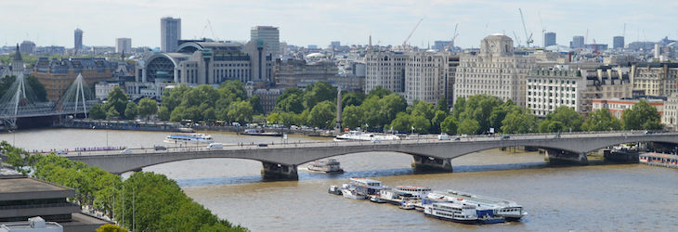

Now create your own representation – you might prefer to do a close-up picture.

Thursday 18th June 2020
English | Big Write Session 1  - Watch the Fantasia video clip: https://www.youtube.com/watch?v=LpKA9n-75tQ As you are watching, encourage your child to think about how the broom came to life and what might happen next. Should Mickey go to sleep? How does the music influence your feelings about the broom?  - Using the sheet, encourage your child to create a list of jobs for each of the kitchen equipment below. How does their look effect the choice of job you give them e.g. could the food mixer pick up a bucket of water? What problems might occur if these items are used for different purposes?
Maths | TT Rockstars  - 30 minutes times table practice each day
Problem Solving Session
- This is a game for two players.
- Introduce the two bags of numbers from either the website: https://nrich.maths.org/10328 or the sheet below. Follow the instructions to play the game.
- You can encourage your child to keep a record of the addition completed using the working out box or they can add the amounts mentally.
- At the end of the game encourage your child to answer the following questions:
- How many numbers did you use altogether in the game?
- Have another go. How many numbers did you use this time?
- What is the largest amount of numbers you could use to reach 37?
- What is the smallest amount of numbers you could use to reach 37?
Wider Curriculum | Termly Topic – lesson 4  - Re-watch the time lapse video of Hungerford Bridge and look at images of the bridge. Encourage your child to talk about how this bridge is different from Waterloo Bridge and the features they can see.  - Using a pencil, draw a representation of Hungerford Bridge as if you are walking across it. Think about how you can show the height of the tension cables using shading and lines (Think back to the previous tutorial on pencil work).
Wider Curriculum | Science - Colour Changing Activity  - Carry out the colour changing milk experiment using the resources below and the website: https://fun-science.org.uk/colour-changing-milk-experiment/  - Watch the video: https://www.youtube.com/watch?v=IUFTqKJpLJ0&feature=emb_logo and encourage your child to discuss what is happening and why.
Active | Joe Wicks- Active session  https://www.youtube.com/channel/UCAxW1XT0iEJo0TYlRfn6rYQ
Thursday – Big Write Session 1

Item: | Jobs that they can do: | Problems that might arise:
Thursday – Problem Solving Lesson

My working out:

Thursday – Topic Lesson 4

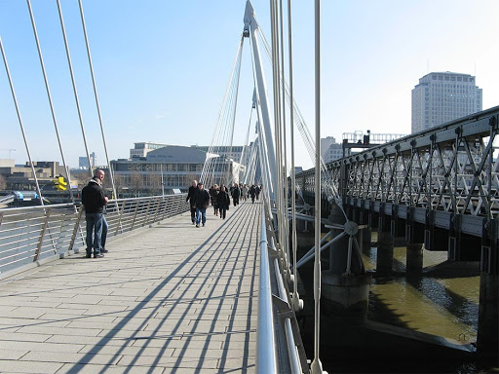

Create your own sketch of Hungerford Bridge.

Thursday – Wider Curriculum Activity

Friday 12th June 2020
English | Big Write Session 2  - Re-watch the video from Fantasia: https://www.youtube.com/watch?v=LpKA9n-75tQ Recep the list of jobs that your child created yesterday – which of the jobs would they most like to do? Which ones would they least like? Why?  - Write the story from the perspective of the broom. Is it happy doing the jobs? Why? Why not? Don’t forget to include speech in your story – maybe Mickey could be giving commands, and the thoughts of each of the characters.  - You could also write a job description for Mickey stating what he needs and why.
Maths | TT Rockstars  - 30 minutes times table practice each day
BBC Bitesize Problem Solving
- Complete the three challenges as a family, encouraging your child to explain how they worked out the answers. They can draw or write their ideas out if that helps!
- At the end encourage your child to create their version of challenge 3 using different shapes and values. Encourage them to challenge a family member or friend to work out the total.

Wider Curriculum | Music Lesson  - Log on to the Charanga home learning portal (details were sent out previously) and complete Week 25 KS2.  - You can choose to complete all of the activities in one session or one/ two at a time.  - Using recycled materials found at home create your own musical instrument or create a marching song for a Roman gladiator.
Active | Cosmic yoga session  https://www.youtube.com/user/CosmicKidsYoga

Friday – Big Write Session 2

__________________________________________________________________________________________________________________________________________________________________________________________________________________________________________________________________________________________________________________________________________________________________________________________________________________________________________________________________________________________________________________________________________________________________________________________________________________________________________________________________________________________________________________________________________________________________________________________________________________________________________________________________________________________________________________________________________________________________________________________________________________________________________________________________________________________________________
Friday – Problem Solving Session

